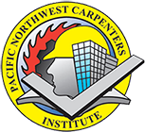
Looking for a GREAT career opportunity?

Apply for a Carpentry Apprenticeship…

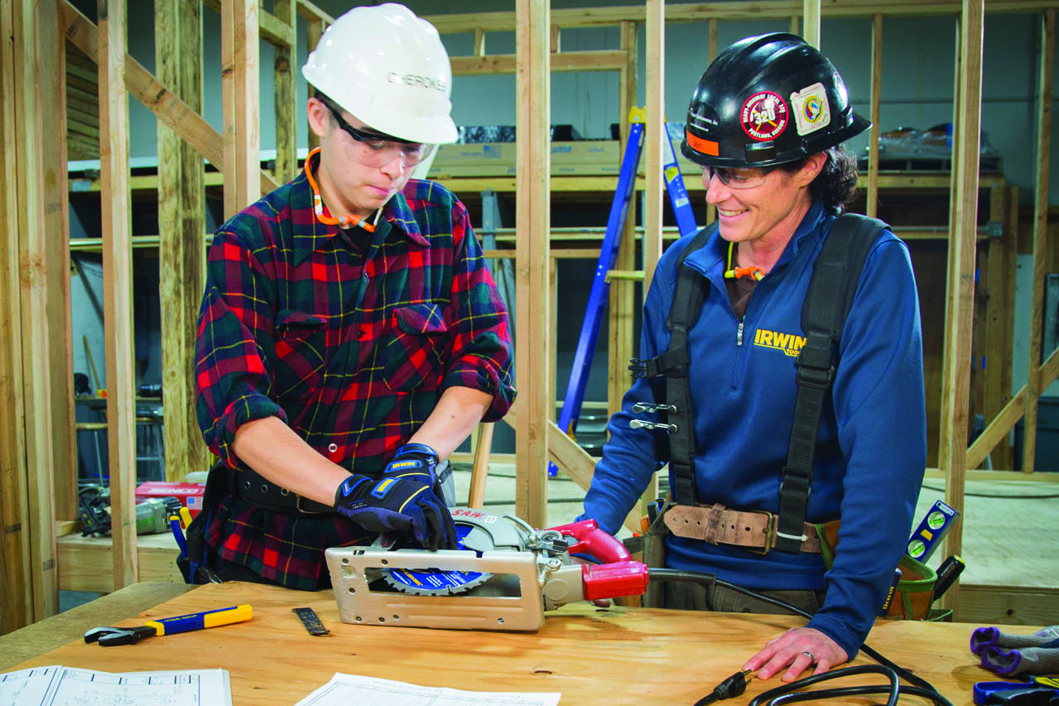

What is a Carpenter?
Look around you! Just about every building has been built by skilled carpenters. To be a carpenter is to be a member of one of the most respected trades. You can build a lifetime career in carpentry. Remember the next time you walk into your home, your school and the mall where you shop they were all built by carpenters

What do you need to become a Carpenter?
Good math skills, great attendance, eagerness and the willingness to work hard.

How do you learn Carpentry?
Apply online for an apprenticeship at the Pacific Northwest Carpenters Institute.

What is an Apprentice?
An apprentice is someone who is being paid while learning a trade by working under the guidance of
skilled workers, called journeymen and going to school.

Pay and Benefits:
The rewards of apprenticeship training are good wages and benefits you receive as a union member. You’ll be working under the protection of a union contract for a good contractor, which means you will have some form of health insurance and pension benefits. It pays to be a union apprenticeship carpenter.

For More Information Contact:

Pacific Northwest Carpenters Institute
4222 NE 158th Avenue
Portland, OR 97230

Apply Online: www.pnci.org Careers Apprenticeship

Call us if you have questions: 503-287-3708

